Argumentative Essay Rubric
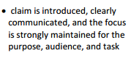
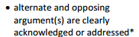
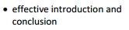
/2pts Do you have a thesis/claim?
Write it here: _______________________________ _______________________________________________________________________________________________________________________________________
/2pts Does your intro have the author and title in the first sentence? Underline it in green? _______
/2 pts Did you explain the story in the first paragraph? ________ Underline it in orange.
/1pt Does your essay flow? _______________
/1pt. Did you write to your audience and not use personal pronouns? (I, me , we, us)_______
/2pts. Does your essay make sense? _____________
/2pts Does your conclusion give a counterargument? “Some might argue …” Underline that in purple.
/2pts Did you explain the rebuttal? However,….Underline that in blue.
/1pt. Did you read it aloud to an adult? ______
/1pt. (Signature) ___________________
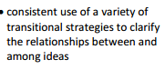
/4pts. Did you use a transition between new ideas?____
List four transitions here and highlight them in yellow on your paper.
_________________ __________________
_________________ _________________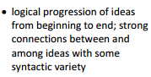
/5pts Paragraph #2
Topic Sentence-underline in orange__________
Underline evidence or quoted sentence # 1 in red .
Warrants? Did you explain how the evidence supports the claim? Underline this is in green.
Did you cite your source with (author’s last name and page number)? Underline this in yellow.
Concluding Sentence/Underline this in blue. _____
/5pts Paragraph #3
Topic Sentence-underline in orange__________
Underline evidence or quoted sentence # 1 in red .
Warrants? Did you explain how the evidence supports the claim? Underline this is in green.
Did you cite your source with (author’s last name and page number)? Underline this in yellow.
Concluding Sentence/Underline this in blue. _____
/5pts Paragraph #4
Topic Sentence-underline in orange__________
Underline evidence or quoted sentence # 1 in red .
Warrants? Did you explain how the evidence supports the claim? Underline this is in green.
Did you cite your source with (author’s last name and page number)? Underline this in yellow.
Concluding Sentence/Underline this in blue. _____
/5pts grammar/Spelling
Total : /40 points

